University of Central Punjab
Faculty of Information Technology

Assignment 3

Course Title: Artificial Intelligence
Course Code: CSAL3243
Name | Registration#

Submission Requirements
- Format: The assignment must be handwritten and submitted as a single document (PDF or Word recommended) in softcopy.
- Integrity: This is an individual assignment. Any evidence of plagiarism or sharing of assignment will result in a zero grade.
- Due Date for Assignment is May 24th, 2026.
- NO LATE SUBMISSION.

CLO# | Course Learning Outcome (CLO) | Taxonomy Level | Mapping to PLO
CLO 2 | To design and implement AI applications that solve real-world problems. | C3 | PLO3

Total Marks =40

Question 1:
Assume we have the following function
𝑓(𝑥) = 𝑥3 − 60𝑥2 + 900𝑥 + 100
where x is constrained to [0 − 31]. We wish to maximize 𝑓(𝑥) (the optimal is 𝑥 = 10). Using a binary representation we can represent 𝑥 using five binary digits.
Given the following four chromosomes give the values for 𝑥 and 𝑓(𝑥).
Chromosome | Binary String
P1 | 11100
P2 | 01111
P3 | 10111
P4 | 00100
- If P3 and P2 are chosen as parents and we apply one point crossover show the resulting children, C1 and C2. Use a crossover point of 1 (where 0 is to the very left of the chromosome)
- Do the same using P4 and P2 with a crossover point of 2 and create C3 and C4
- Calculate the value of x and f(x) for C1 to C4.
Assume the initial population was 𝑥 = {17, 21, 4, 28}. Using one-point crossover, what is the probability of finding the optimal solution? Explain your reasons.
Question 2:
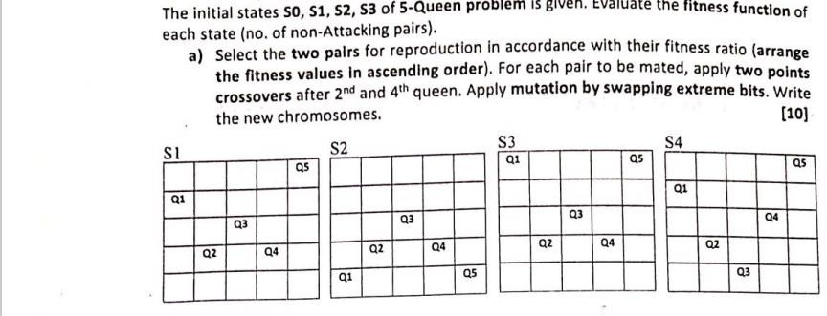

Question 3:
The Travelling salesman Problem: “Given a list of cities and the distances between each pair of cities, what is the shortest possible route that visits each city and returns to the origin city?”
Consider the following graph in which cites are described by alphabets : A,B.C,D,E. The distance between each is given on the edges.
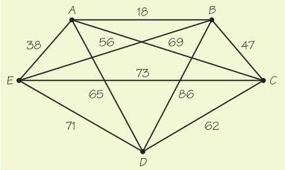
Use Genetic algorithm to answer the following questions.
- How many genes will be used in a chromosome of each individual?
- For TSP problem, consider the following two routes as parents. Apply order-based crossover on index 2 to 4 (index starts from 0).
P1: BCAED P2: ADBCE
- The mutation for TSP can be defined as a swap between two indices. Now apply mutation at index 1 and 3 on both parents.
- Perform genetic algorithm for 1 generation/iteration. You can start with initial population of 4 chromosomes.

Question 4:
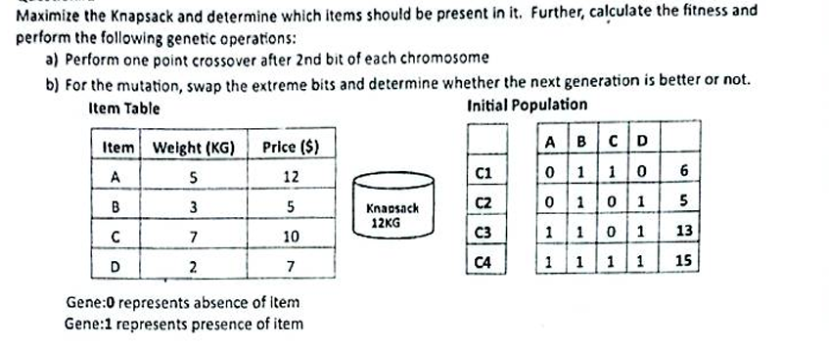

BEST OF LUCK

